Chapter 6
The Memory Hierarchy
To this point in our study of systems, we have relied on a simple model of a computer system as a CPU that executes instructions and a memory system that holds instructions and data for the CPU. In our simple model, the memory system is a linear array of bytes, and the CPU can access each memory location in a constant amount of time. While this is an effective model as far as it goes, it does not reflect the way that modern systems really work.
In practice, a memory system is a hierarchy of storage devices with different capacities, costs, and access times. CPU registers hold the most frequently used data. Small, fast cache memories nearby the CPU act as staging areas for a subset of the data and instructions stored in the relatively slow main memory. The main memory stages data stored on large, slow disks, which in turn often serve as staging areas for data stored on the disks or tapes of other machines connected by networks.
Memory hierarchies work because well-written programs tend to access the storage at any particular level more frequently than they access the storage at the next lower level. So the storage at the next level can be slower, and thus larger and cheaper per bit. The overall effect is a large pool of memory that costs as much as the cheap storage near the bottom of the hierarchy, but that serves data to programs at the rate of the fast storage near the top of the hierarchy.
As a programmer, you need to understand the memory hierarchy because it has a big impact on the performance of your applications. If the data your program needs are stored in a CPU register, then they can be accessed in zero cycles during the execution of the instruction. If stored in a cache, 1 to 30 cycles. If stored in main memory, 50 to 200 cycles. And if stored in disk tens of millions of cycles!
Here, then, is a fundamental and enduring idea in computer systems: If you understand how the system moves data up and down the memory hierarchy, then you can write your application programs so that their data items are stored higher in the hierarchy, where the CPU can access them more quickly.
This idea centers around a fundamental property of computer programs known as locality. Programs with good locality tend to access the same set of data items over and over again, or they tend to access sets of nearby data items. Programs with good locality tend to access more data items from the upper levels of the memory hierarchy than programs with poor locality, and thus run faster. For example, the running times of different matrix multiplication kernels that perform the same number of arithmetic operations, but have different degrees of locality, can vary by a factor of 20!

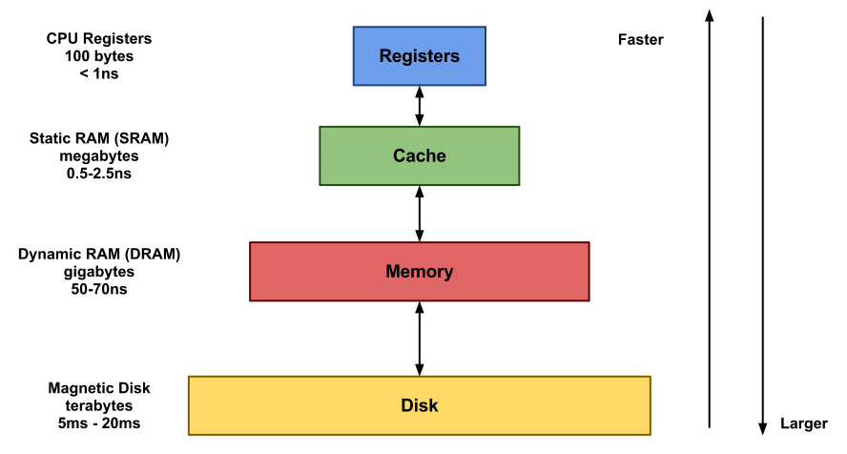
It can be noted that the larger the memory, the slower the data access.

6.1 Storage Technologies
Much of the success of computer technology stems from the tremendous progress in storage technology. Early computers had a few kilobytes of random-access memory. The earliest IBM PCs did not even have a hard disk. That changed with the introduction of the IBM PC-XT in 1982, with its 10-megabyte disk. By the year 2010, typical machines had 150,000 times as much disk storage, and the amount of storage was increasing by a factor of 2 every couple of years.
Glosario: To stage: montar / manipular

EJERCICIO 1
- Lea el texto completo con atención e indique en qué párrafo se mencionan las siguientes ideas (Parte 6):

- Ciclos requeridos para acceder a la información Párrafo IV
- Rol de la memoria principal. Párrafo II
- Importancia de la localidad. Párrafo VI

- Marque con un  los conceptos que están definidos en el texto.
- Computer system ✔
- Memory system ✔
- Caché memory X
- Locality ✔
- Storage devices X

EJERCICIO 2
Lea el texto nuevamente y decida si las siguientes afirmaciones son correctas.

- Toda la información que es frecuentemente usada se encuentra en los registros de la CPU. SI / NO
- La primera Computadora Personal IBM consistía en un disco duro. SI / NO
- Para acceder a los datos almacenados en un disco, se necesitan más de un millón de ciclos. SI / NO
- Un programador debe estar familiarizado con la jerarquía de memoria. SI / NO
- Los adelantos en la tecnología de almacenamiento han beneficiado el desarrollo de la tecnología de las computadoras. SI / NO

EJERCICIO 3
Encierre en un círculo a qué refieren las palabras resaltadas en el texto.

It CPU / model
they hierarchies / programs
their application programs / data items
them application programs / data items
That a few kilobytes of ….. memory / The earliest IBM PCs did not …a disk

